**3.3 Persistence Algorithm**

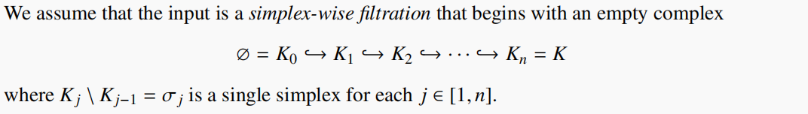

Note:

1. Any filtration can be expanded into a simplex-wise filtration.
2. The persistence diagram of the original filtration can be read from the diagram of this expanded simplex-wise filtration.

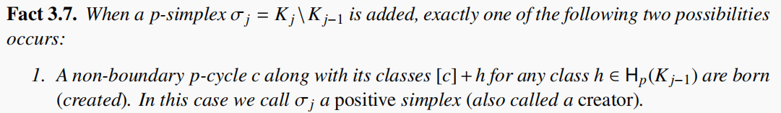

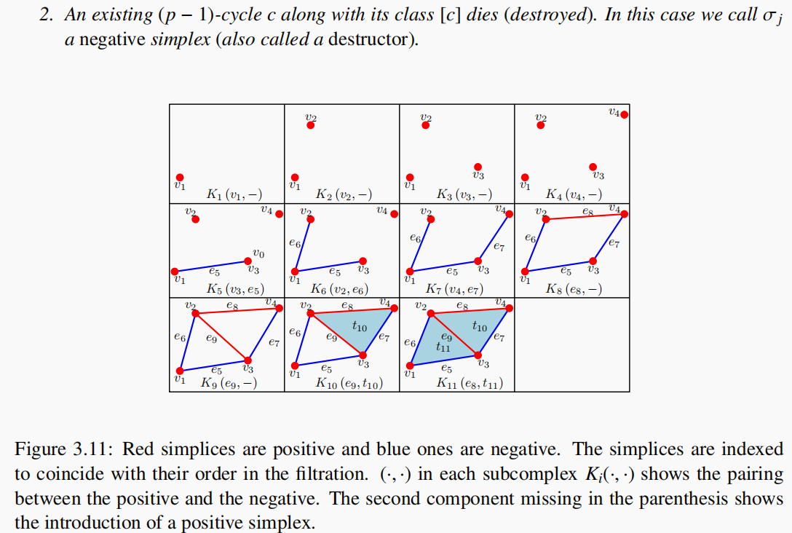

Note:

1. A creator can only create one independent p-cycle and the others are its linear combinations with the existing ones in K_j−1.(see K9)
2. for a creator, the p-betti number increases 1, and for a destructor,the (p-1)-betti number decrease 1.
3. Why only these two case? If it is not a destructor, it’s boundary must be the boundary of another existed chain since a simplex can be added only when its facets(boundary) have been added already.Thus, this new simplex creates a p-cycle with the existed chain.

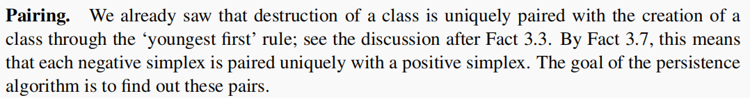

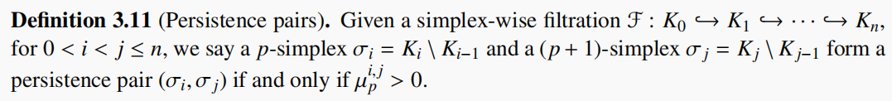

Note:

1. persistent pairing number: the number of **independent** classes.
2. persistent pair:no need of independence.**But we are going to find out independent pairs.**
3. **Direct algorithm**

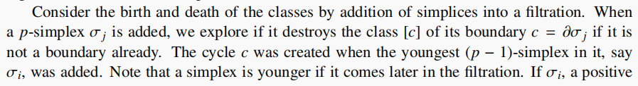

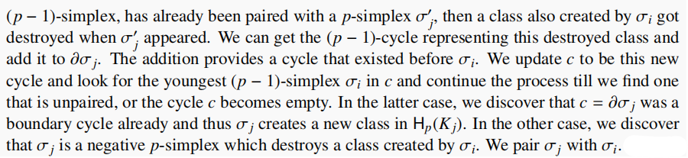

example:

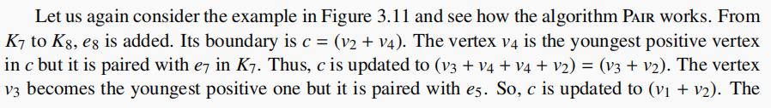

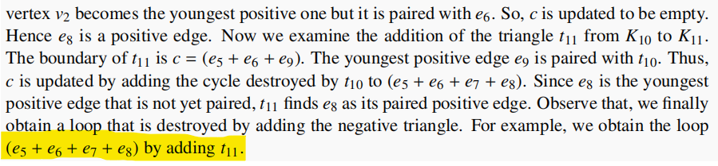

矩阵算法的直观就是从这个算法来的。

1. **Matrix reduction algorithm**



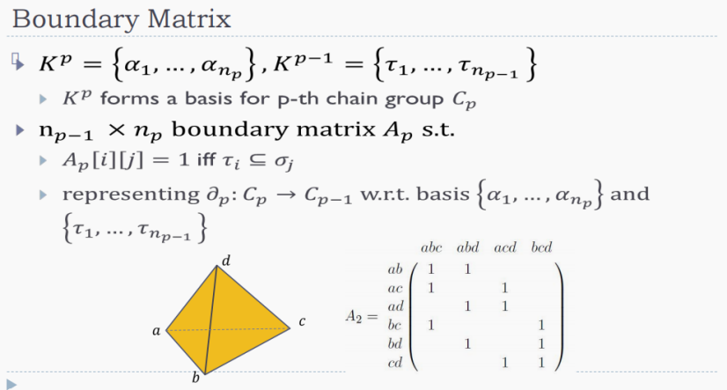

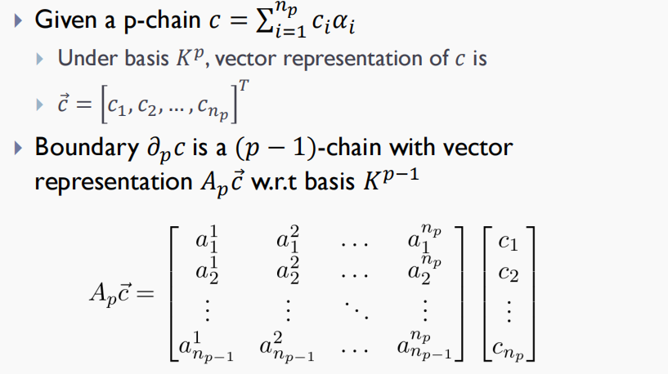

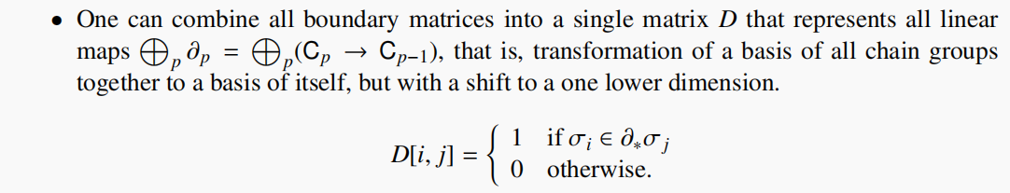

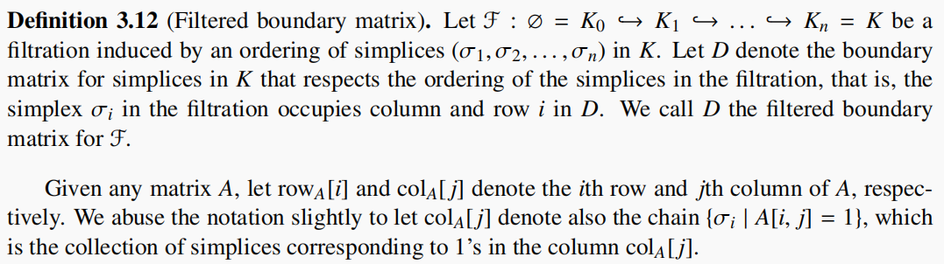

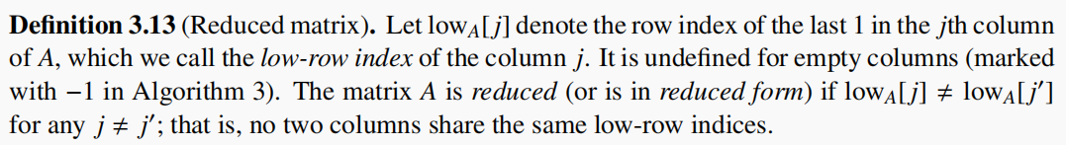



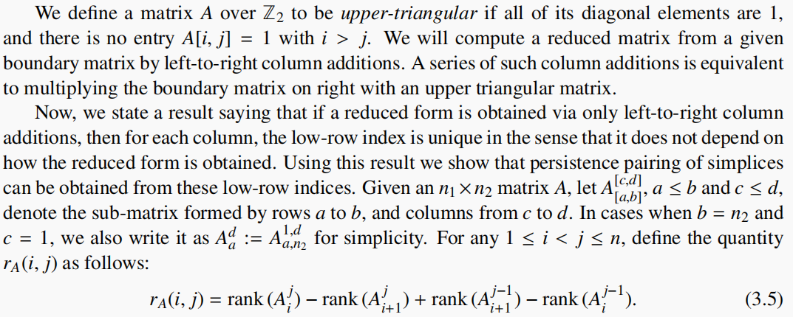



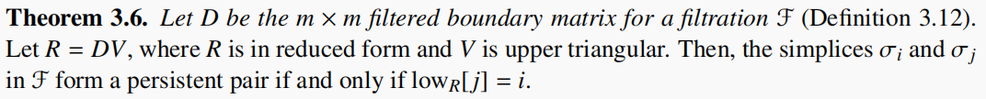

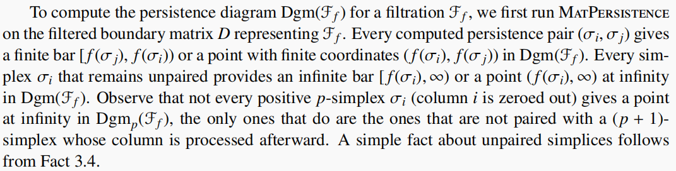



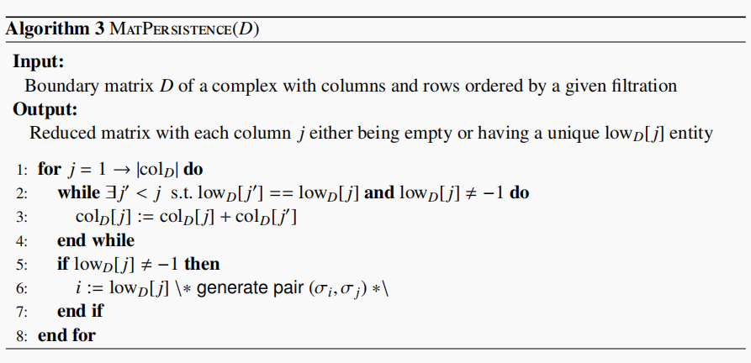

Complexity:O(N^3)，N is the number of simplex.

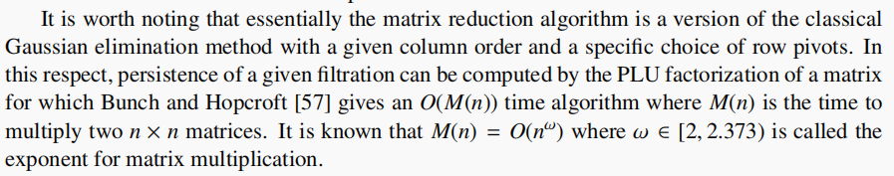

**proof of theorem 3.6:**

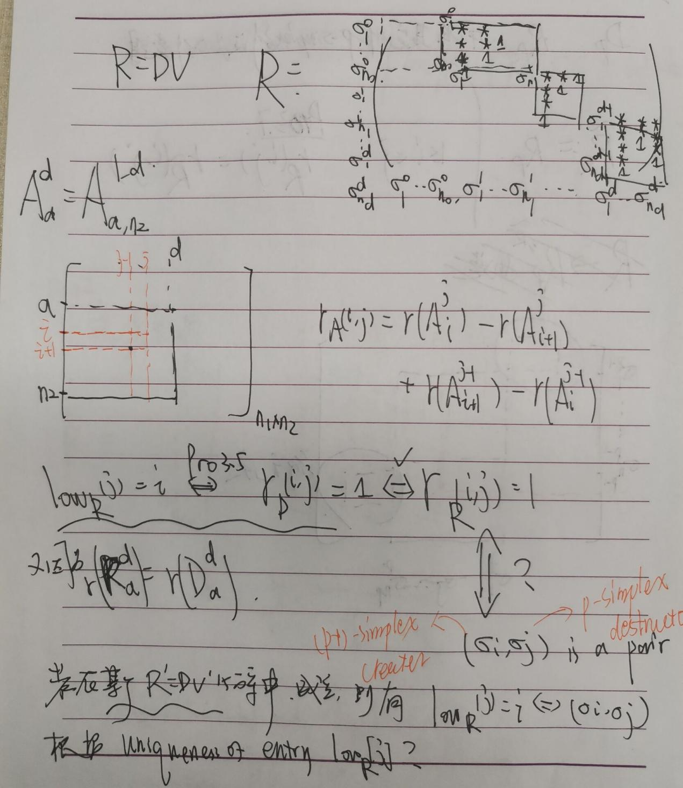

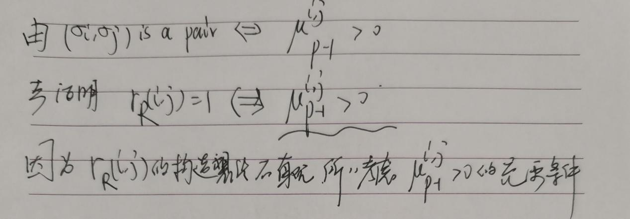

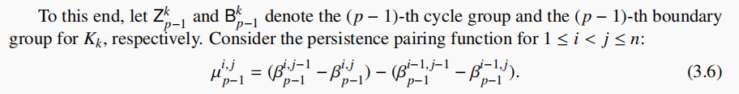

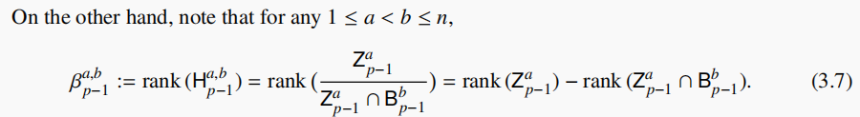

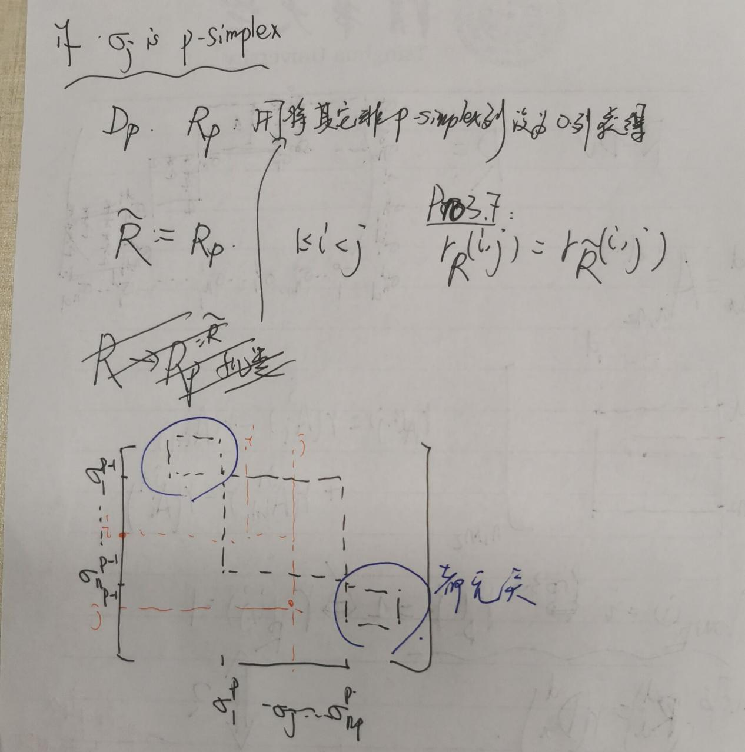

这样做的原因，我们只需要考察Dp，只是把所有p放在一起写成一个大矩阵才使用D。

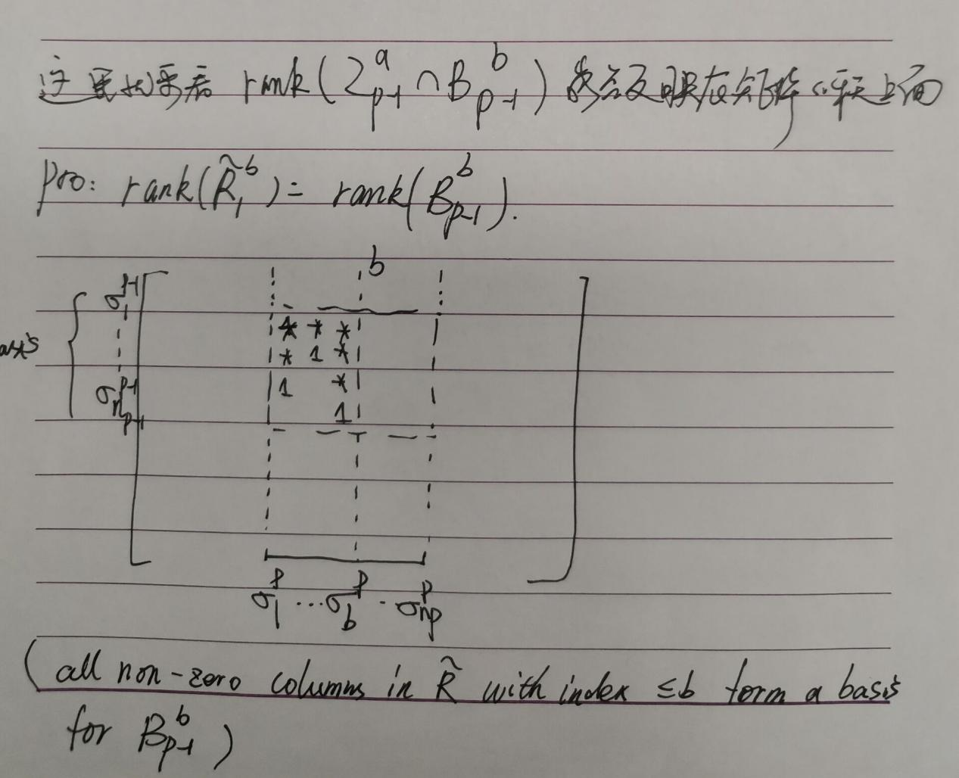

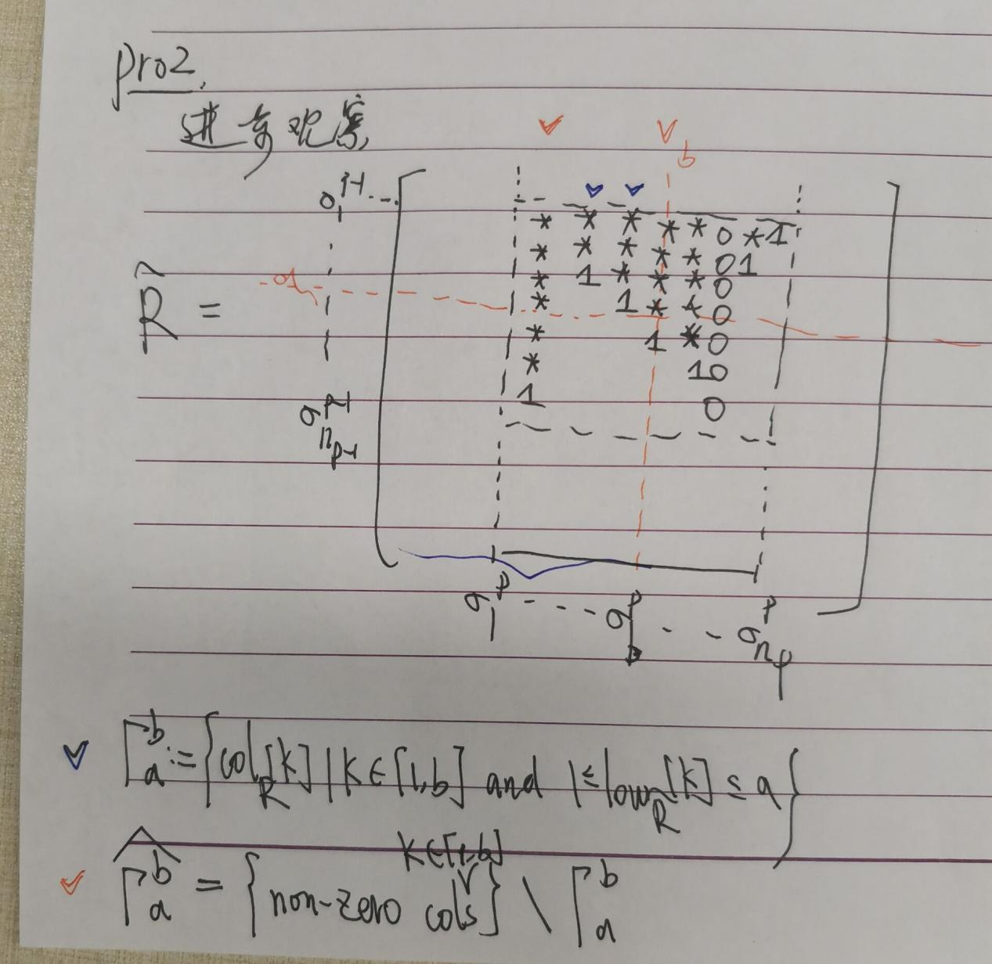

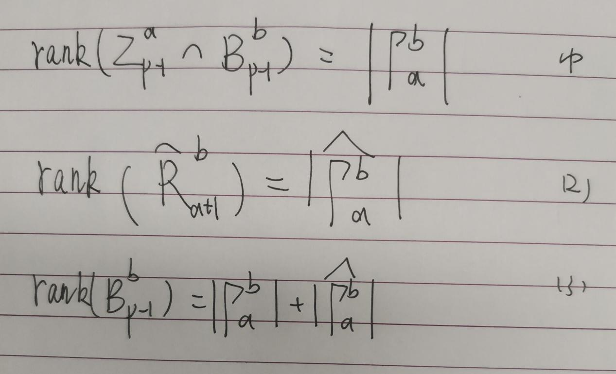

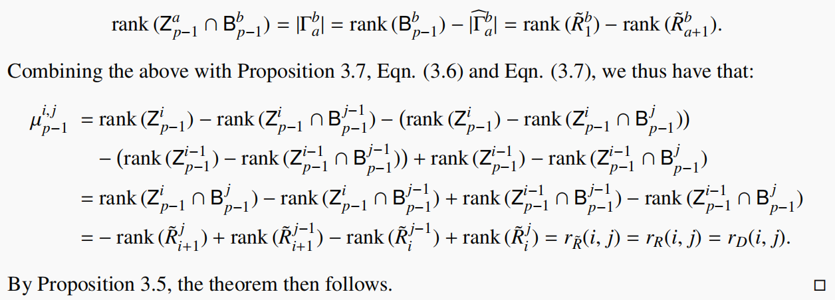

最后，补上之前的一个证明：

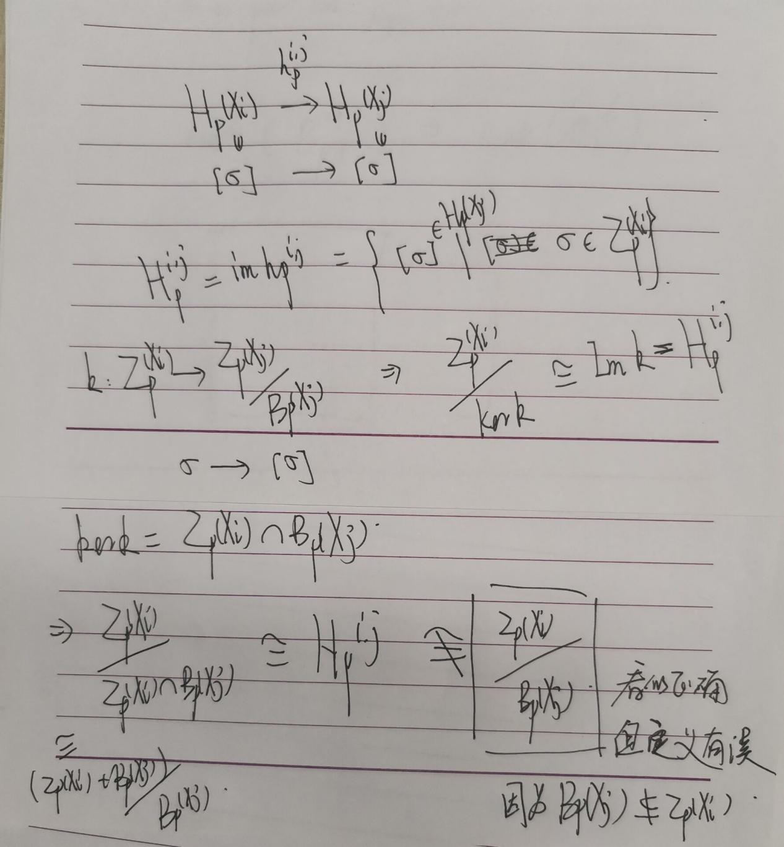

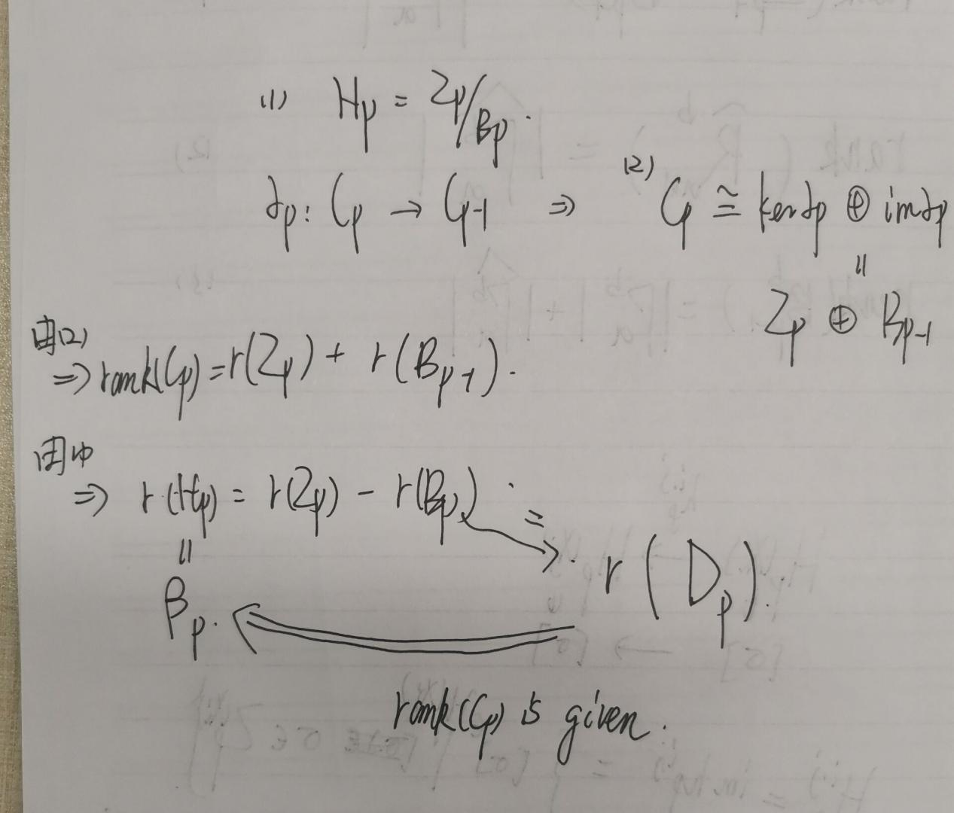

1. **Efficient implementation**

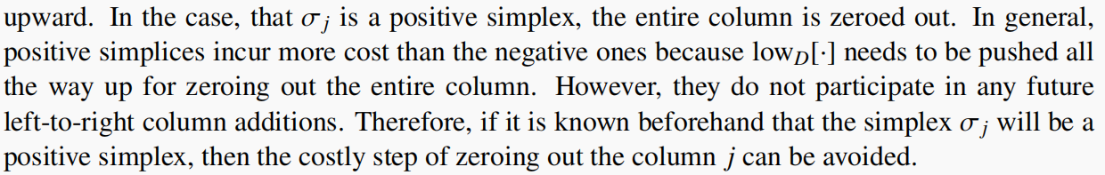

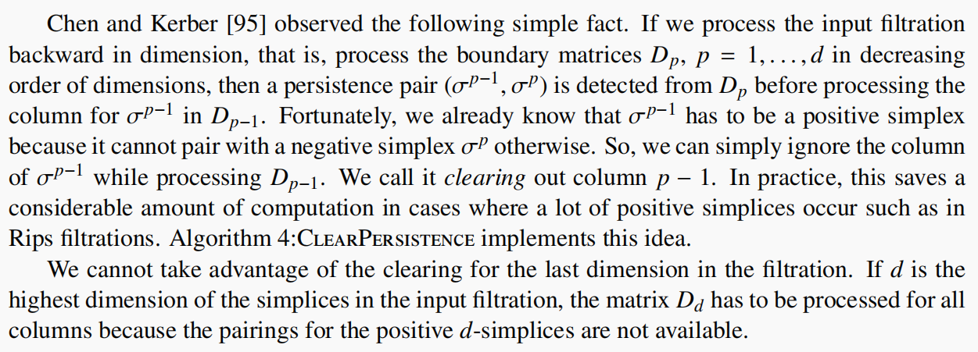

**note:**

**if we can clear the column of σj, then it adds to a p-cycle. Otherwise, it destroys a (p-1)-cycle.**

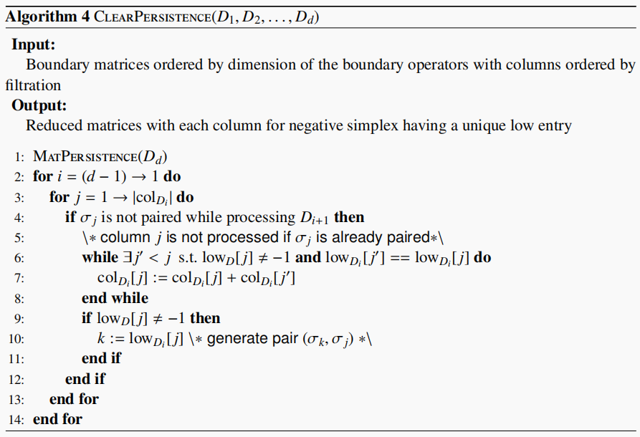

**如果Dd很大，而D1很小，则倒过来做cleaning：**

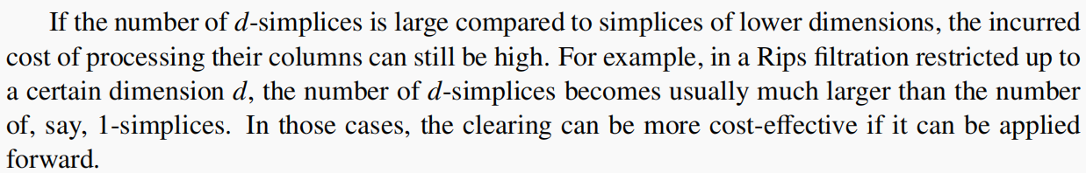

**twisted matrix** :

